V1.3 升级文档

Thursday, October 30, 2014

10:43 AM

1. 关闭Truscreen系统

1. 升级数据库系统
   1. 登录Mysql数据库

打开命令行窗口，输入 mysql -u truscreen -p 后，回车，输入密码.如下图

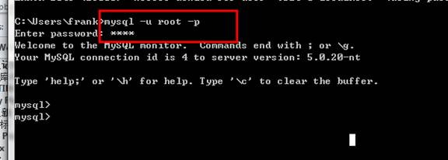

1. 输入sql语句
   1. 输入命令 use report， 回车

C:\Users\frank\AppData\Local\Temp\msohtmlclip1\02\clip_image002.jpg

1. 输入 ALTER TABLE report ADD prescribingDoctorName VARCHAR(128); 回车。注意这儿是英文分号结尾

C:\Users\frank\AppData\Local\Temp\msohtmlclip1\02\clip_image003.jpg

1. 输入 ALTER TABLE report ADD COLUMN (lct VARCHAR(128), hpv VARCHAR(128) ,touchbleeding VARCHAR(128) );
2. 上面三步放一起就是

Machine generated alternative text: Select Administrator: - mysql -u root -proot 
icrosoFt Windows [Uersion 6 ] 
opyright (c) 2009 Microsoft Corporation . 
: VJsers NFrank>mysqI —u root —proot 
All rights reserved. 
elcome to the MySQL monitor. 
Commands end with • 
or • 
our MySQL connection id is 2 
eruer version: 5.5 .41 MySQL Community Server (GPL) 
opyright (c) 2øøø. 2014. Oracle and/or its affiliates. All rights reserved. 
racle is a registered trademark OF Oracle Corporation and/or 
F Filiates. Other names may be trademarks OF their respective 
ype ' help;' 
or ' For help. Type ' to clear the current 
its 
input statement. 
ysql> use report 
atabase chan ed 
s ALTER TABLE report 
uery OK. 
Ows affected 
ecords: 
s ALTER TABLE report 
uery OK. 
rows affec 
ecords: 
ysql> 
RD prescribingDoctorName U ARCHRR(128) ; 
( 02 sec) 
arnings: 
ADD 
(0.02 sec) 
(Ict URRCHRR(128). 
hpu URRCHRR(128) -touchbleeding URRCHRR(128) 

1. 然后关了窗口。
2. 升级服务端jar包
   1. 拷贝server-side.jar 到 D:\truscreen\lib 如果安装在C盘，那么就拷贝到 C:\truscreen\lib
3. 升级前端
   1. 拷贝文件夹 web\js 和 web\partials 到D:\truscreen\bin\web
4. 升级完成，启动系统